Practical No.05

Q.1] Write code to display a message when a button is clicked.

XML code:

<?xml version="1.0" encoding="utf-8"?>
<LinearLayout xmlns:android="http://schemas.android.com/apk/res/android"
xmlns:app="http://schemas.android.com/apk/res-auto"
xmlns:tools="http://schemas.android.com/tools"
android:id="@+id/main"
android:orientation="vertical"
android:gravity="center"
android:layout_width="match_parent"
android:layout_height="match_parent"
tools:context=".MainActivity">
<Button
android:id="@+id/button"
android:layout_width="wrap_content"
android:layout_height="wrap_content"
android:layout_margin="20dp"
android:text="Show"
/>
<TextView
android:id="@+id/textView"
android:layout_width="wrap_content"
android:layout_height="wrap_content"
android:layout_margin="20dp"
android:text="Hello DYP"
/>
</LinearLayout>

Java code:

package com.techtitans.madpracticals;
import android.os.Bundle;
import android.view.View;
import android.widget.Button;
import android.widget.TextView;
import androidx.activity.EdgeToEdge;
import androidx.appcompat.app.AppCompatActivity;
import androidx.core.graphics.Insets;
import androidx.core.view.ViewCompat;
import androidx.core.view.WindowInsetsCompat;
public class MainActivity extends AppCompatActivity {
@Override
protected void onCreate(Bundle savedInstanceState) {
super.onCreate(savedInstanceState);
EdgeToEdge.enable(this);
setContentView(R.layout.activity_main);
TextView txt = findViewById(R.id.textView);
Button btn = findViewById(R.id.button);
btn.setOnClickListener(new View.OnClickListener() {
@Override
public void onClick(View view) {
txt.setText("Button is Clicked");
}
});
}
}

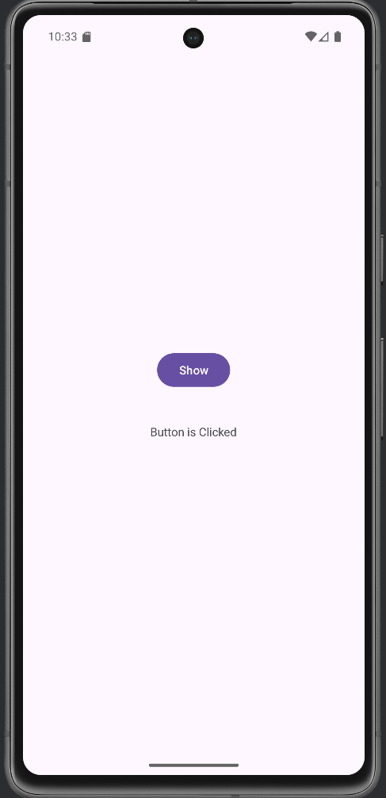
output :-

Q.2] Create a layout with all three buttons: Button,ImageButton and ToggleButtton.
XML code :
<?xml version="1.0" encoding="utf-8"?>
<LinearLayout xmlns:android="http://schemas.android.com/apk/res/android"
xmlns:app="http://schemas.android.com/apk/res-auto"
xmlns:tools="http://schemas.android.com/tools"
android:id="@+id/main"
android:orientation="vertical"
android:gravity="center"
android:layout_width="match_parent"
android:layout_height="match_parent"
tools:context=".MainActivity">

<Button
android:id="@+id/button"
android:layout_width="wrap_content"
android:layout_height="wrap_content"
android:layout_margin="20dp"
android:text="Click"
/>
<ImageButton
android:id="@+id/imageButton"
android:layout_width="wrap_content"
android:layout_height="wrap_content"
android:layout_margin="20dp"
app:srcCompat="@drawable/img_1" />
<ToggleButton
android:id="@+id/toggleButton"
android:layout_width="wrap_content"
android:layout_height="wrap_content"
android:layout_margin="20dp"
android:text="ToggleButton" />
</LinearLayout>

Java code:
package com.techtitans.madpracticals;
import android.os.Bundle;
import androidx.activity.EdgeToEdge;
import androidx.appcompat.app.AppCompatActivity;
import androidx.core.graphics.Insets;
import androidx.core.view.ViewCompat;
import androidx.core.view.WindowInsetsCompat;
public class MainActivity extends AppCompatActivity {
@Override
protected void onCreate(Bundle savedInstanceState) {
super.onCreate(savedInstanceState);
EdgeToEdge.enable(this);
setContentView(R.layout.activity_main); }}
Output :-
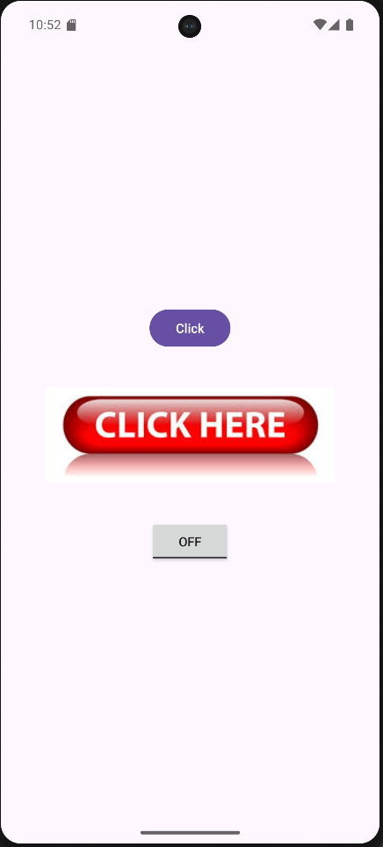

Q.3] Change TextView Based On Toggle.
XML code :-
<?xml version="1.0" encoding="utf-8"?>
<LinearLayout xmlns:android="http://schemas.android.com/apk/res/android"
xmlns:app="http://schemas.android.com/apk/res-auto"
xmlns:tools="http://schemas.android.com/tools"
android:id="@+id/main"
android:orientation="vertical"
android:gravity="center"
android:layout_width="match_parent"
android:layout_height="match_parent"
tools:context=".MainActivity">
<Button
android:id="@+id/button"
android:layout_width="wrap_content"
android:layout_height="wrap_content"
android:layout_margin="20dp"
android:text="Click" />
<ImageButton
android:id="@+id/imageButton"
android:layout_width="304dp"
android:layout_height="101dp"
android:layout_margin="20dp"
app:srcCompat="@drawable/img_1" />
<ToggleButton
android:id="@+id/toggleButton"
android:layout_width="wrap_content"
android:layout_height="wrap_content"
android:layout_margin="20dp"
android:text="ToggleButton"
android:textOff="WIFI OFF"
android:textOn="WIFI ON" />
<TextView
android:id="@+id/textView2"
android:layout_width="wrap_content"
android:layout_height="wrap_content"
android:layout_margin="20dp"
android:textSize="25sp"
android:text="Hello" />
</LinearLayout>

Java code :-
package com.techtitans.madpracticals;
import android.os.Bundle;
import android.view.View;
import android.widget.TextView;
import android.widget.ToggleButton;
import androidx.activity.EdgeToEdge;
import androidx.appcompat.app.AppCompatActivity;
public class MainActivity extends AppCompatActivity {
@Override
protected void onCreate(Bundle savedInstanceState) {
super.onCreate(savedInstanceState);
EdgeToEdge.enable(this);
setContentView(R.layout.activity_main);
TextView txt = findViewById(R.id.textView2);
ToggleButton tg = findViewById(R.id.toggleButton);
tg.setOnClickListener(new View.OnClickListener() {
@Override
public void onClick(View view) {
if (tg.isChecked()) {
txt.setText("WIFI is ON!");
} else {
txt.setText("WIFI is OFF!");
}
}
});
}
}

output :-
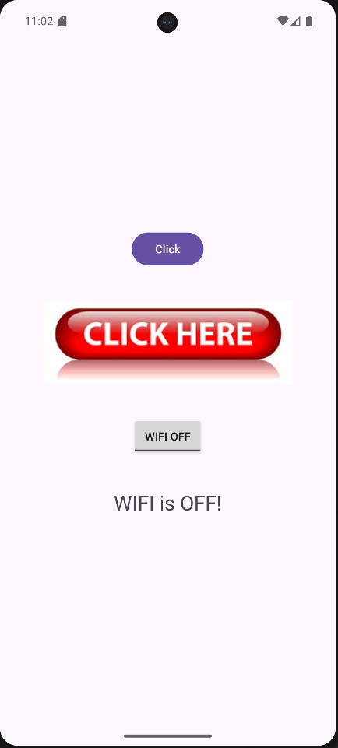
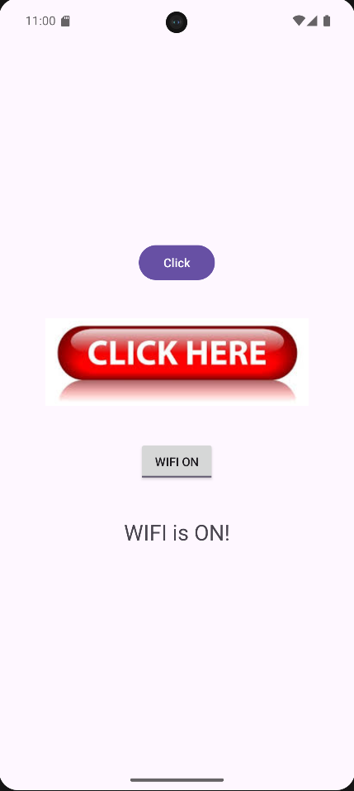

Q.4] Image Button Interaction
I. Add an Image Button using an image from the draw able folder
II. On Click, display a Toast message: “Image Button Pressed.”
XML code :
<?xml version="1.0" encoding="utf-8"?>
<LinearLayout xmlns:android="http://schemas.android.com/apk/res/android"
xmlns:app="http://schemas.android.com/apk/res-auto"
xmlns:tools="http://schemas.android.com/tools"
android:id="@+id/main"
android:orientation="vertical"
android:gravity="center"
android:layout_width="match_parent"
android:layout_height="match_parent"
tools:context=".MainActivity">
<Button
android:id="@+id/button"
android:layout_width="wrap_content"
android:layout_height="wrap_content"
android:layout_margin="20dp"
android:text="Click" />
<ImageButton
android:id="@+id/imageButton"
android:layout_width="309dp"
android:layout_height="137dp"
android:layout_margin="20dp"
app:srcCompat="@drawable/img_1" />
<ToggleButton
android:id="@+id/toggleButton"
android:layout_width="wrap_content"
android:layout_height="wrap_content"
android:layout_margin="20dp"
android:textOff="WIFI OFF"
android:textOn="WIFI ON"
android:text="ToggleButton"/>
<TextView
android:id="@+id/textView2"
android:layout_width="wrap_content"
android:layout_height="wrap_content"
android:layout_margin="20dp"
android:textSize="25sp"
android:text="Hello" />
</LinearLayout>

Java code:
package com.techtitans.madpracticals;
import android.os.Bundle;
import android.view.View;
import android.widget.ImageButton;
import android.widget.TextView;
import android.widget.Toast;
import android.widget.ToggleButton;
import androidx.activity.EdgeToEdge;
import androidx.appcompat.app.AppCompatActivity;
public class MainActivity extends AppCompatActivity {
@Override
protected void onCreate(Bundle savedInstanceState) {
super.onCreate(savedInstanceState);
EdgeToEdge.enable(this);
setContentView(R.layout.activity_main);
TextView txt = findViewById(R.id.textView2);
ImageButton img = findViewById(R.id.imageButton);
img.setOnClickListener(new View.OnClickListener() {
@Override
public void onClick(View view) {
Toast.makeText(getApplicationContext(), "Image Button Press",
Toast.LENGTH_LONG).show();
}
});
ToggleButton tg = findViewById(R.id.toggleButton);
tg.setOnClickListener(new View.OnClickListener() {
@Override
public void onClick(View view) {
if (tg.isChecked()) {
txt.setText("WIFI is ON!");
} else {
txt.setText("WIFI is OFF!");
}
}
});
}
}

Output :
